

***\*\*\*JULY 30, 2022\*\*\****

***6th ANNUAL***

***TSER FAMILY OFFROAD RIDE***

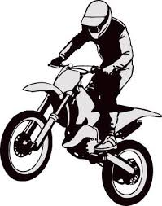

* Beginner Friendly
* MINI and Motorcycles ONLY
* Nice arrowed singletrack
* Many loops, 4-8 Miles in length
* NO Membership cards needed
* Trail Pass-$25 per person (not bike or shared bike)
* NO QUADS/SUV’s-NO EXCEPTIONS!!!
* Walking speed in the pits ONLY
* If you want to rip around, you will be removed
* THIS IS PRIVATE PROPERTY!!!
* FUN RIDE IS SATURDAY ONLY!!!
* Address: 11003 280th St. (Hedrick) GPS: 41.24998, -92.392090
* Arrowed from FREMONT
* Bikes can start at 9:00 a.m. with last bikes out at 4:00 p.m.
* Closed course so no lights/plates necessary
* Contact Number: Larry @ 641-660-4460
* If you enjoy the fun ride, try the enduro on Sunday!!

***JULY 31, 2022***

ENDURO

* Key time is 10:00
* Mileage will be posted closer to time
* Start/Restart Format
* All offroad-No plates or lights required